## **The Special Trick**

The special trick is a state that we can reach through sequence three. The premise behind the trick is to enhance the cap illusion and give us the ability to “disable” the switch.

To enter this state from sequence three, there must be at least two LEDs that are on. Once we enter this state, we pick one of the switches that are on and turn it off, a 4 second timer starts, and when it is over, if the switch is still off, this switch is disabled.

To reenable the switch, we have to once again leave it off for 4 seconds.

To tackle this problem we first need to figure out a way to check which of the turned-on switches was turned off. Luckily, we have our switch state module that gives us the previous state of all our switches.

We can easily detect a falling edge this way.

Denote $S_{i}$ as the current switch state and $P_{i}$ as the previous switch state, thus:

$Falling Edge at i= P_{i}S_{i}$’

We can use this falling edge detector as a trigger for the 4 second timer. Once the timer has set, we must find a way to either disable or enable the switch.

If we recall the multiplexing technique that we used to wire the inputs to the outputs, we know that the special trick state has its own multiplexed selection case. So all we have to do is connect all of our switches to an AND gate with a control input. If this control is 1, this means the switch is enabled and it passes through to the selection. If this control is 0, this means that our switch is disabled, and the LED will never turn on regardless of the state of the switch.

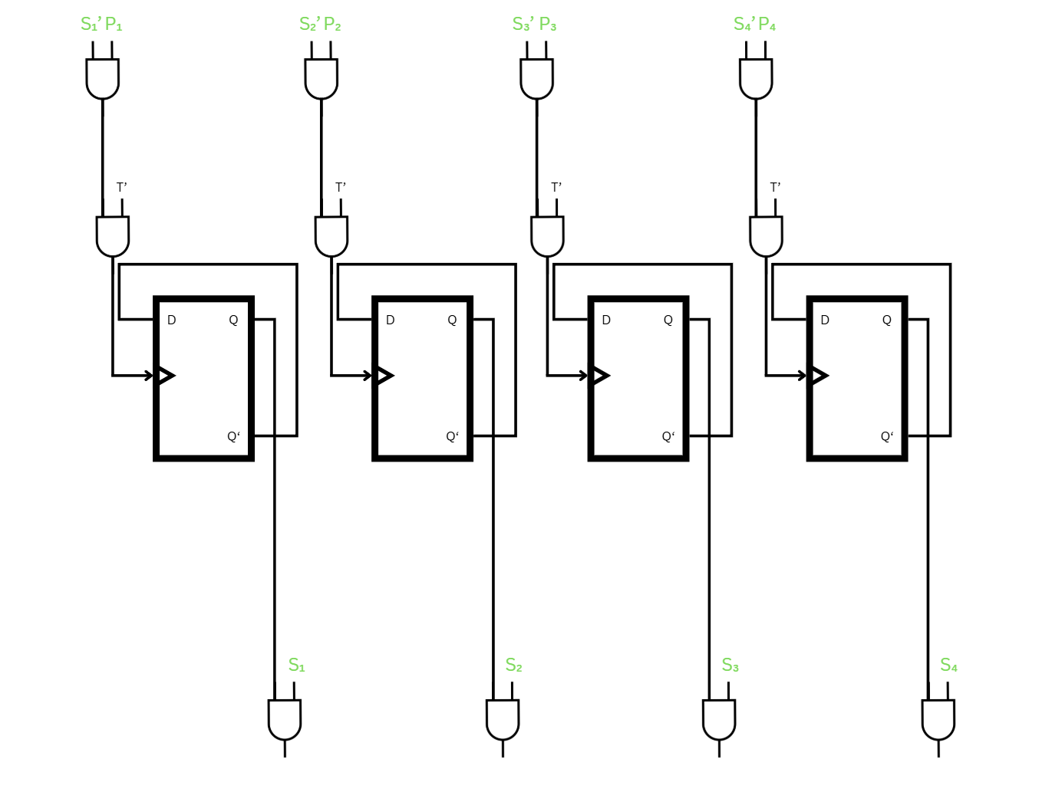

Figure - Special Trick Register Concept

From the figure above we can see the configuration at hand. We have four flip flops that act as registers to store whether a switch is disabled or not. We notice that they have their compliments connected to the input, this means whenever they are triggered their output flips.

This means that no matter what, since whenever we disable a switch, we should reenable it, we trigger the flip flop twice, which resets it to its initial state. By default all flip flops should have a value of 1.

The flip flops are triggered when one of two things occur, the switch experiences a falling edge which we denoted by $P_{i}S_{i}$’ and the timer runs out.

As we can see from the figure the flip flop clocks are connected to an AND expression with these conditions. We note that the timer starts as soon as it detects ANY falling edge.

If we want to take extra measures and ensure that only ONE switch can be disabled at a time we can AND the flip flop outputs with the clock conditions such that if any other flip flop is off another cant be at the same time.